12 - Shanghai Disneyland - Illuminate
“Authentically Disney and Distinctly Chinese”
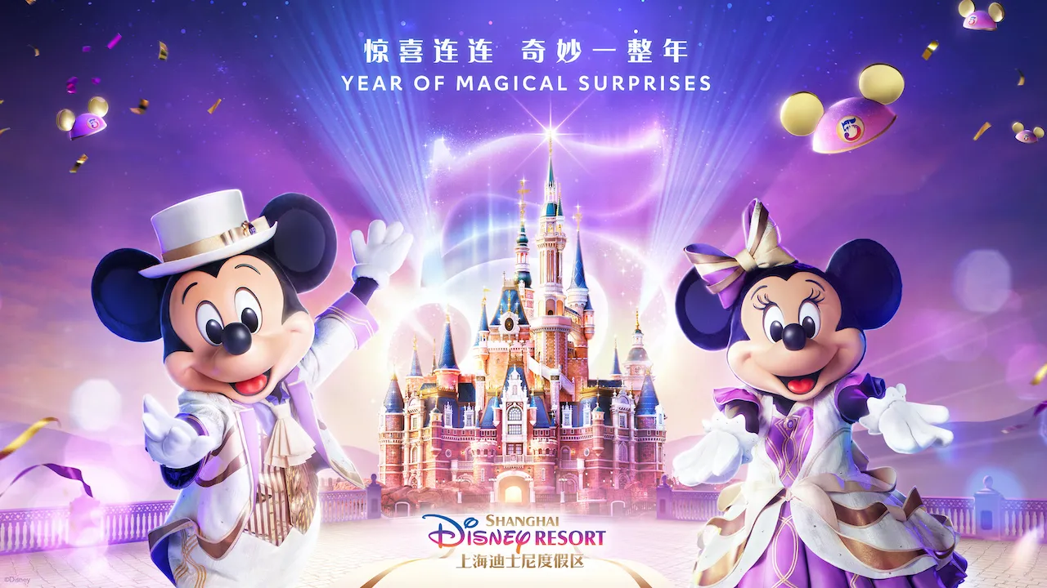

ILLUMINATE! A Nighttime Celebration to Light Up the Night at Shanghai Disneyland With All-New Immersive Show
Shanghai, April 6, 2021 – Five years ago, Shanghai Disney Resort ignited the spark of imagination for its first park guests, and has since gone on to inspire tens of millions of more guests over five years with world-class attractions and shows – including the one and only Ignite the Dream – A Nighttime Spectacular of Magic and Light. In just two days, guests will bid a fond farewell to this beloved Grand Opening version of the resort’s nighttime spectacular and embrace an all-new show – ILLUMINATE! A Nighttime Celebration. Set to debut at Shanghai Disneyland’s Enchanted Storybook Castle on April 8, the new show will immerse guests in a completely original entertainment experience, combining cutting-edge technologies and brand-new content to create a truly immersive Disney storytelling finale to complete an unforgettable visit to Shanghai Disneyland.
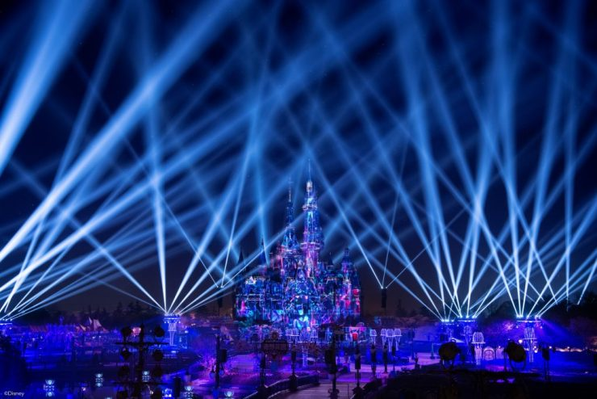
“For our 5th Birthday Celebration, we wanted to create an exceptional experience for our guests to thank them for making our first five years so memorable,” said Joe Schott, President and General Manager of Shanghai Disney Resort. “The new nighttime spectacular leveraged the talent of over 70 Disney experts and consultants from eight countries, employed some of the world’s advanced technologies, and incorporated some of our most beloved stories to create a truly immersive and magical conclusion to a day at Shanghai Disneyland.”
Creativity, technology, storytelling and innovation combine in magical new ways
ILLUMINATE! A Nighttime Celebration builds on Disney’s legacy of combining creativity with technology and innovation to bring beloved characters and stories to life in magical new ways. Centered around a theme of light, ILLUMINATE! is designed to make guests feel that the entire park is enchanted with light – a light that is at the very heart of our dreams and wishes and which is giving life to the very park itself. Once again featuring Shanghai Disneyland’s iconic landmark – Enchanted Storybook Castle – the new nighttime spectacular will also take advantage of the beautifully decorated Gardens of Imagination to fully immerse guests in an entertainment experience unlike any other. Surrounded by breathtaking audio-visual elements, guests will feel like they are at the center of every show as it plays throughout the Gardens of Imagination.
To create this incredible immersive effect, 91 lighting fixtures, including eight giant new towers, 11 enhanced garden arbors, and 12 electronic lily pads have been installed across 15 new locations throughout the park. 22,000 new LED lights have been installed onto the new towers and arbors, adding to the 5,000 lights that were already in the garden, totaling 27,000 points of light for the new show. The lighting effect also leverages synchronized lighting from the Dumbo the Flying Elephant and Fantasia Carousel attractions, as well as the parade route to further enhance the experience. A grand water display will also be presented in front of the castle, employing 38 static fountains, seven moving fountains, and one water screen, while 27 fire burst locations and six lasers installed around the castle will add pyrotechnic and lighting elements to this stunning audio-visual experience.
Featuring projection mapping, pyro, flames, fountains, lasers, lighting and more, the new nighttime spectacular will feature all the exciting elements guests have come to love as part of a nighttime spectacular, while also incorporating a whole new range of surprise immersive innovations.
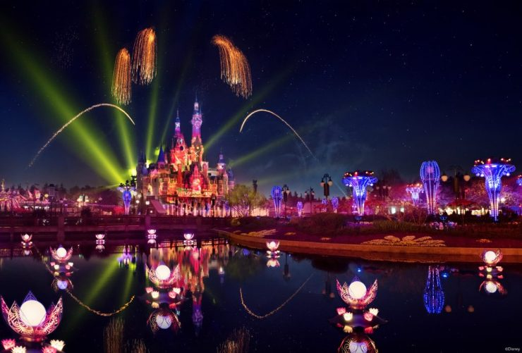
Classic and New Disney Characters bring guests on a journey through adversity to find the light within
Throughout Disney’s 100 years of storytelling, every lead character has carried within them a light that drives them towards their dreams and a brighter future. As night falls at Shanghai Disneyland, ILLUMINATE! A Nighttime Celebration will invite guests to embark on a journey alongside more than 80 characters from over 40 films from Walt Disney Animation Studios, Pixar Animation Studios and Marvel Studios, including those from the most recent hits – “Soul” and “Raya and the Last Dragon” – to search for the light within.
Comprised of seven unique chapters, ILLUMINATE! A Nighttime Celebration will take guests on a daring journey, beginning with an original song titled “Light Is In You.” As this stunning visual story progresses, guests can experience the flame for a better future being lit, echoing scenes from “Brave”, “Aladdin”, “Big Hero 6” and more, before adversity comes crashing down, in an attempt to conceal the light as it did to Mulan, Miguel from “Coco,” Simba from “The Lion King”, and so many other characters. ILLUMINATE! will then inspire guests to break through the darkness and see the light, before stepping out from the adversity alongside Buzz and Woody from “Toy Story”, Joy and Sadness from “Inside Out”, Rapunzel from “Tangled”, Elsa, Anna and Olaf from “Frozen” and so many more. In a moving conclusion, Judy from “Zootopia”, Elsa from “Frozen,” Moana, and more will deliver a message of perseverance, encouraging guests to hold onto the light that exists within all of us and trust it to see them through.
As part of the new experience, nine songs, including reimagined takes on beloved Disney classics, and an exciting new composition specially created for this extraordinary nighttime spectacular, called “Light is in You”, will provide a nostalgic backdrop from which a stunning visual story will spring to life.
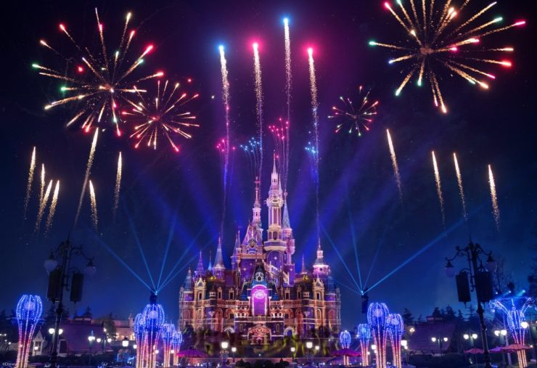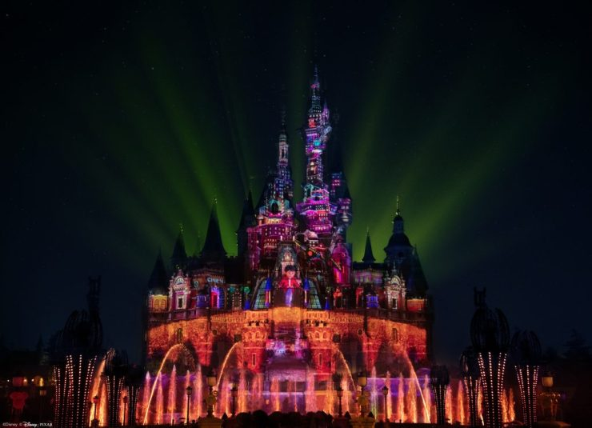
Debut of Marvel Super Heroes on a Disney castle
No search for light and battle against the darkness would be complete without the participation of Marvel’s Super Heroes, and for the first time ever on any Disney castle, guests can enjoy a range of Marvel Super Heroes assembling as part of a nighttime spectacular.
From Avengers including Iron Man, Captain America, Hulk, Captain Marvel, Thor, Black Widow, Hawkeye and Black Panther, to the Guardians of the Galaxy such as Groot, and many more, this exclusive chapter midway through each performance will pay homage to 15 Marvel characters.
With five years of unforgettable memories, Shanghai Disneyland’s iconic nighttime show has long served as an unforgettable conclusion to many guests’ visits. ILLUMINATE! A Nighttime Celebration will build on this legacy, redefining live entertainment for the industry while continuing to deliver a breathtaking multi-sensory experience that will stay with guests for years to come.
https://monorailnews.com/2021/04/08/illuminate-a-nighttime-celebration-to-light-up-the-night-at-shanghai-disneyland-with-all-new-immersive-show/

- 91 lighting fixtures, including eight giant new towers, 11 enhanced garden arbors, and 12 electronic lily pads have been installed across 15 new locations throughout the park to create a truly immersive experience
- 22,000 new LED lights have been installed onto the new towers and arbors, adding to the 5,000 lights that were already in the garden, totaling 27,000 points of light for the new show
- The grand water display in front of the castle features 38 static, seven moving fountains and one water screen
- 27 fire burst locations and six lasers feature at different locations around the castle and Gardens
- Beloved characters from over 40 films from Walt Disney Animation Studios, Pixar Animation Studios and Marvel Studios are set to feature
- This is the first time in history that Marvel characters will appear on a Disney castle, with 15 Superheroes set to assemble
- Nine songs are played throughout the show, including one original composition and several new reimaginings of beloved Disney classics
- Over 70 Cast Members and consultants from eight countries were involved in the creation of the show
- https://mouseinfo.com/2021/04/sneak-peek-stunning-new-illuminate-show-lights-the-night-for-shanghai-disneys-5th-anniversary/

