9 – Tokyo DisneySea – Fantasmic

April 28, 2011 – February 28, 2020

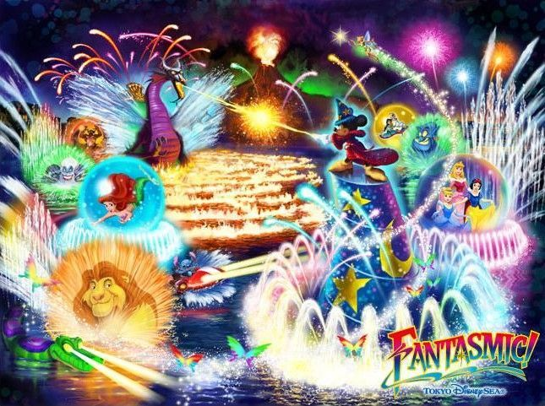

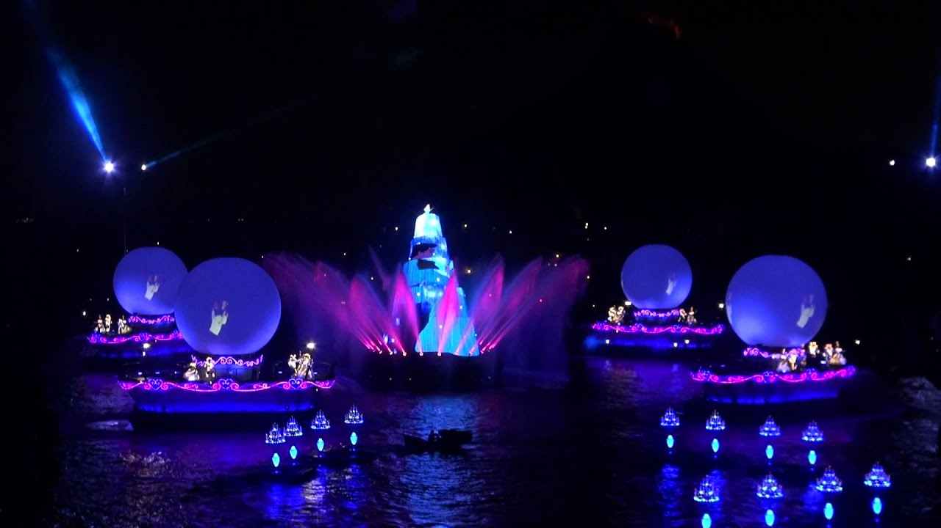

Fantasmic! debuted at Tokyo DisneySea on April 28, 2011, replacing the BraviSEAmo! show in the Mediterranean Harbor. The show was originally planned to debut on April 23 with the park's 10th Anniversary "Be Magical!" celebration, but was delayed by the Great East Japan Earthquake in March 2011. Originally, Fantasmic! was planned in 2001 for the park and the story would be themed around Tokyo DisneySea but was scrapped and instead DisneySea Symphony debuted. Many of the barges were reused from Tokyo DisneySea's former nighttime Christmas show “Candelight Reflections” but were reimagined. The Christmas tree barge was used for Mickey's sorcerer hat. This barge would also be used for Tokyo DisneySea's former nighttime Christmas show “Colors of Christmas” (2012-2019). The natural gas line in the harbor and 5 water cannons originally used for BraviSEAmo! were also repurposed.
The show's score was recorded by the Royal Philharmonic Orchestra at Abbey Road Studios, composed by Don L. Harper, featuring Bruce Healey's theme from the original Fantasmic! at the US parks. The DisneySea version has new scenes and narrative elements, including scenes based on Aladdin, Finding Nemo, and Cinderella, and the original new song "Imagination". This is the only version of Fantasmic! to not have a stationary stage, with the show taking place entirely on barges. All of the characters' dialogue and sung parts were recorded in Japanese by the characters' respective Japanese voice artists.
This version of Fantasmic! closed on February 28, 2020. It was originally scheduled to conclude its run on March 25, 2020, but was moved up due to the extended closure of Tokyo Disney Resort in response to the COVID-19 pandemic in Japan.
https://en.wikipedia.org/wiki/Fantasmic!

