9 – Disneyland – Fantasmic

May 13, 1992 – Jan 11, 2016 ** July 17, 2017 – Mar 12, 2020 ** 2022 - ?

(Florida -- Oct 15, 1998 – Mar 12, 2020 ** Sep 5, 2021 - ?)

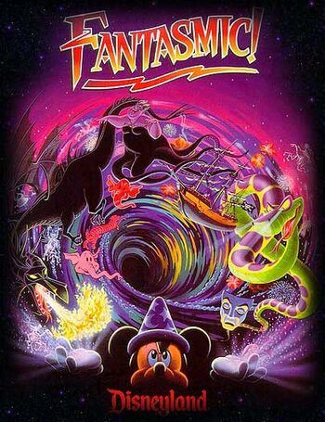

“Welcome to Fantasmic! Tonight, our friend and host, Mickey Mouse, uses his vivid imagination to create magical imagery for all to enjoy. Nothing is more wonderful than the imagination, for, in a moment, you can experience a beautiful fantasy or an exciting adventure. But beware, nothing is more powerful than the imagination, for it can also expand your greatest fears into an overwhelming nightmare. Are the powers of Mickey's imagination strong enough, and bright enough, to withstand the evil forces that invade Mickey's dreams? You are about to find out. For we now invite you to join Mickey, and experience Fantasmic!... a journey beyond your wildest imagination.”

“Some imagination, huh? Ha ha!”

Fantasmic! is a long-running nighttime show at both Disneyland in California and Disney's Hollywood Studios in Florida, now recently added to Tokyo DisneySea. It is about the power of the imagination, showcased by Mickey experiencing a dream during a night in which he is sleeping. It originated at Disneyland in 1992 after Disneyland's entertainment department was asked to create a nighttime spectacular involving water and fireworks to invigorate the space in front of the Rivers of America. Disneyland Entertainment employed the resources of Walt Disney Feature Animation and Walt Disney Imagineering as collaborators. Much of the area around the Rivers of America needed to be reworked, including terracing the walkways to accommodate viewing and modifying part of Tom Sawyer Island so that it could act as a stage for much of the show's live-action.
