8 – Disneyland Paris – Disney Dreams

April 2, 2012 – March 24, 2017

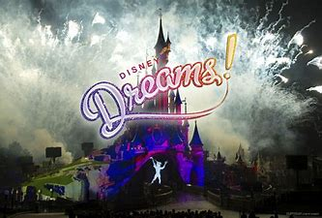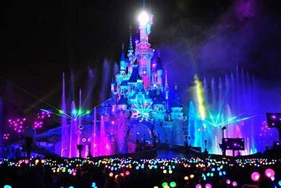

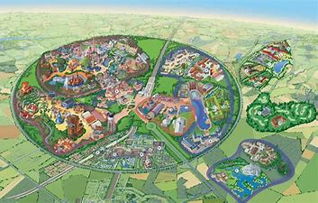
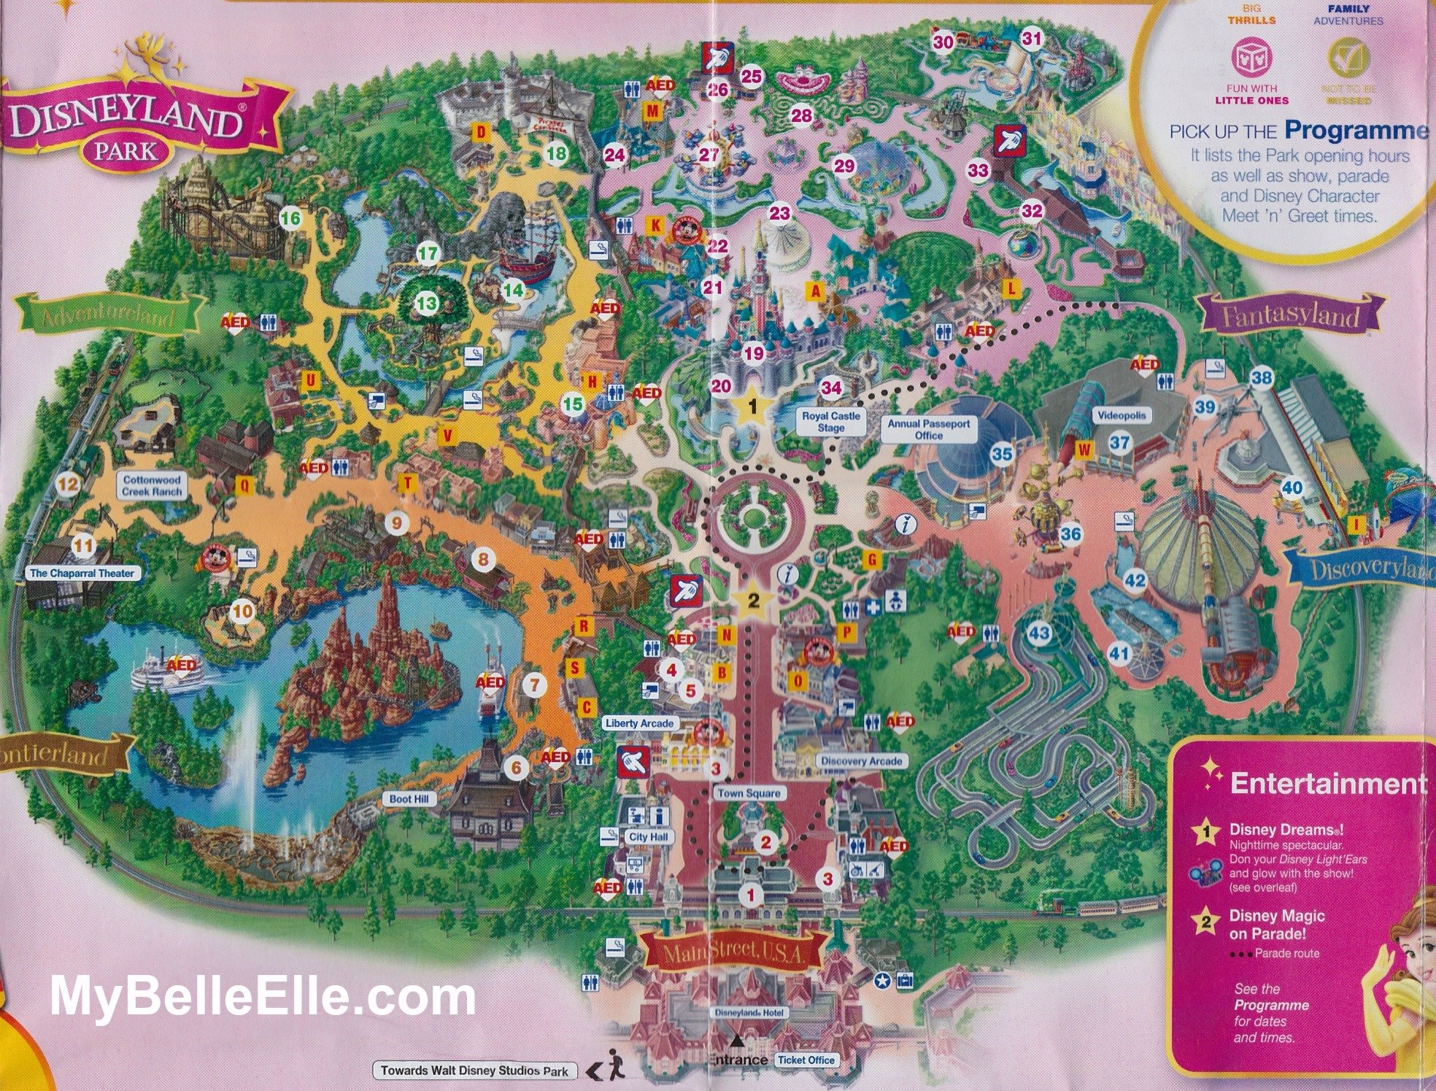

Technology
The show is known to use a large amount of audio-visual, lighting, pyrotechnic and hydrotechnic technology.
The show is controlled from a specially built control room, delivered by special convoy and themed as a small Victorian House in the central plaza, facing the castle. 70 km of fibre optics allow the show to be managed from this location. The show is operated by a main controller with three technicians to look after audio, video and special effects. However other technicians are placed at around the Castle to ensure the smooth running of the show, especially at the firing points. In total, twenty people are necessary at each performance.

Projection
16 Christie Projectors are used throughout the show to projection map onto the 2,500sqm castle which has been 3D scanned to create a computer model. Four projectors are installed on the roof of Main Street buildings, with an additional eight in purpose-built locations around the moat and viewing area. The other four are used to project onto the water screens either side of the moat. Windscreen wipers are in use to keep the projection glass clear. Although no exact details have been released by Disney, a behind the scenes video on their official YouTube channel shows a GrandMA2 and Hippo Media Servers, Hippotizers, in use in the control booth for the show.

Lighting
Three 'Skytracer' moving lights have been installed either side of the Castle for ariel effects while four lasers are used on the roofs of main street, in the castle and inside the 'Second Star to the Right' at the top of the castle.
Thanks to a patented technology, since Summer 2013, audience members can now take part in the show with Disney Dreams Light'Ears that are synchronised with the show using Infrared technology.

Pyrotechnics
The two main firework launch points are located on the roofs of Fantasyland while Pyrotechnics are used on the castle itself.^{[7]} There are a total of 58 launching points on the castle and a further 18 behind it. 15 isopar flamethrowers with telescopic arms are located around the castle building, projecting fire up to 15 meters into the air, with heat that can be felt by the audience. Each flamethrower has a weather station that prevents the device from firing in unsuitable weather conditions, in order to prevent damage to the castle.

Hydrotechnics
Disney Dreams! utilises 37 fixed and 6 moving fountains which are capable of firing water up to 40 meters high. Featuring LEDs at their base, the patented designs have been used at Disney California Adventure in World of Color. Additionally, two retractable mist screens make up projection surfaces used periodically throughout the show. These systems use recycled water from the castles moat while a fog generator operates with drinking water for hygiene purposes.
https://disney.fandom.com/wiki/Disney_Dreams!

