# 6 - Overview – Shanghai Disneyland – *Opening Gala*

***“Authentically Disney and Distinctly Chinese”***

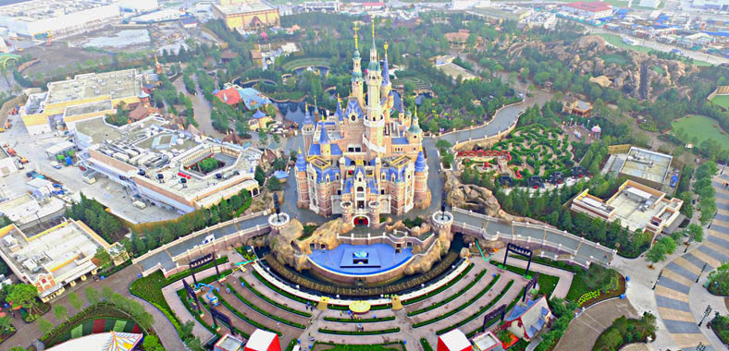

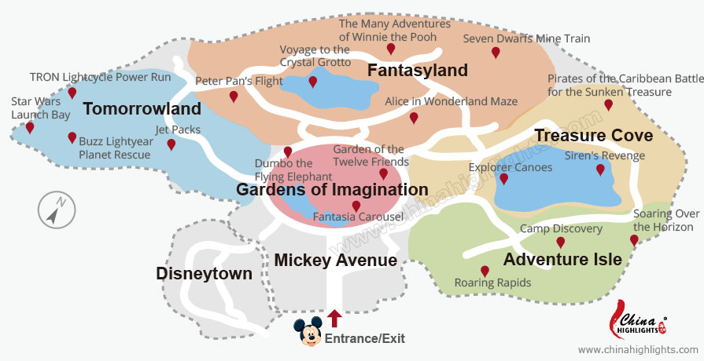

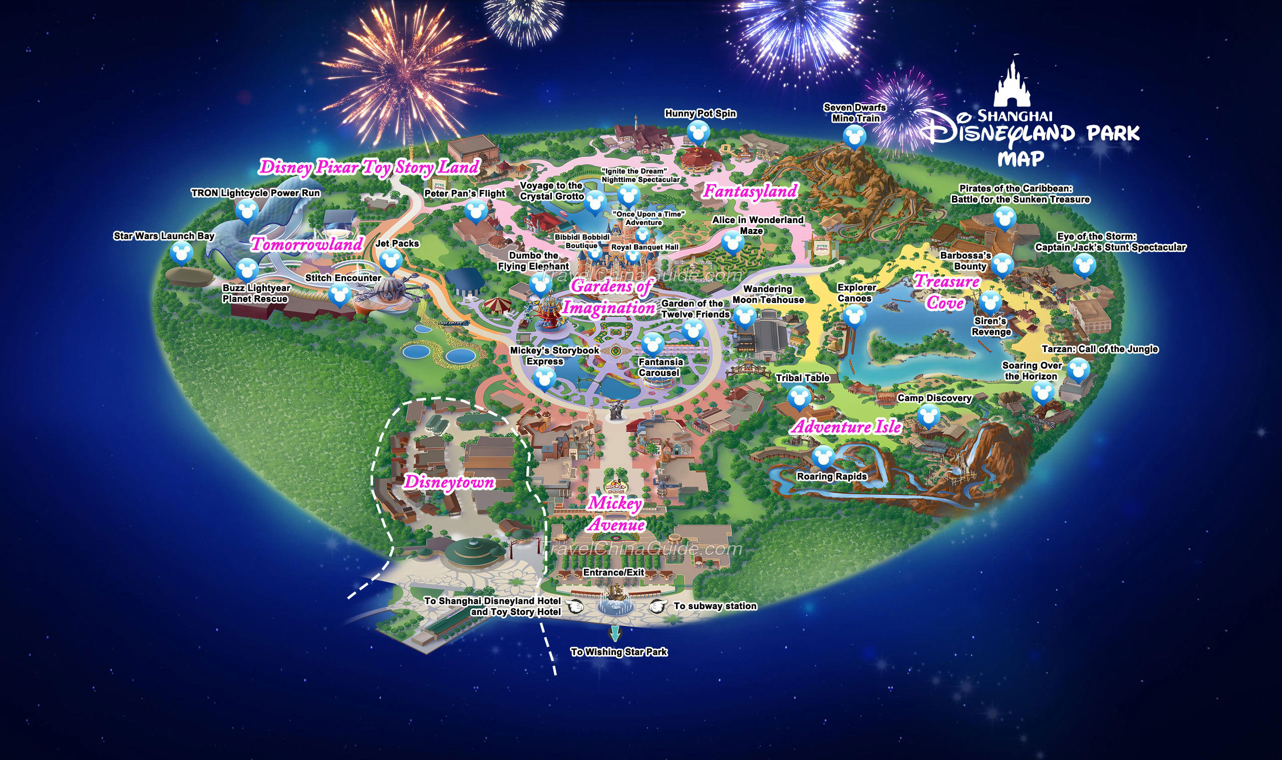

***Castle of Magical Dreams – 167 Ft --- 12 Princesses + 2 Frozen heroines***

