4 : “BravaSEAmo” -- Tokyo DisneySea

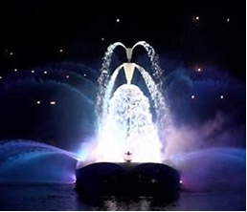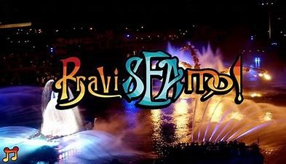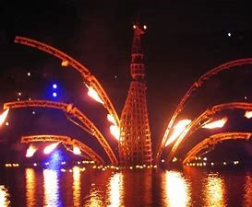

July 17, 2004 -- November 13, 2010

BraviSEAmo! was a nighttime water show at Tokyo DisneySea. The show featured water, pyrotechnic, and firework effects and was performed on the lagoon of the Mediterranean Harbor. The show was directed by Yves Pépin from ECA2 and used little dialogue, instead featuring an orchestral score by Gavin Greenaway. BraviSEAmo! replaced Tokyo DisneySea's earlier nighttime show DisneySea Symphony and was replaced by a new version of Fantasmic! in 2011.

Synopsis
The show begins with the lights around Mediterranean Harbor darkening, and a pre-show musical portion plays while mist blows across the lagoon. As the pre-show ends, a horn call is heard, and spotlights form a large pentagram in the sky. Mickey Mouse then enters in an aquatic chariot pulled by sea horses. Mickey is dressed as a sea prince, with a flowing robe, a crown of large golden tasseled feathers, and a trident.
After sailing around the lagoon, Mickey welcomes the audience "to this world of magic," sending fireworks out of his trident as low-level fireworks blanket the water in sparks. He asks if the audience wonders how such a mysterious place exists, and if they want to know the story "that only the Sea and Wind know." Mickey and chariot exit as a Male Narrator describes the story: In the far distant past, a Water Spirit and a Fire Spirit lived in this place, but each inhabited its own world without ever seeing the other's face. The story, and show, tell of their first meeting.
Fountains then begin to spray on the lagoon from stationary barges, forming water patterns in time with the gentle music of the Water Spirit Bellisea. This proceeds for several minutes until the music fades. It is replaced by the wordless female voice of Bellisea, who appears on the water in the form of a woman made from flowing water. Bellisea moves through the lagoon on a barge, her appearance created by water spraying from a metal scaffold to form her arms, hair, and skirt from water. After reaching the far end of the lagoon, the music fades and Bellisea disappears into slumber.
An aggressive drumbeat and thunder sound ring out as fireworks launch from Mount Prometheus, the volcano located adjacent to Mediterranean Harbor. Plumes of fire then shoot from the lagoon as the music speeds in intensity. The sound of male chanting, representing the voice of the Fire Spirit Prometeo, rings out as he emerges from under the water in the form of a mechanical phoenix. Fire burns on the lagoon in a rune-like shape, and flames shoot from Prometeo's wings. After remaining on the water for a moment, Prometo begins to retire.
It is then that Bellisea, reawakening, starts to sing from her end of the lagoon. Prometeo, taking notice, looks over to her. Bellisea continues to sing, and Prometeo joins, their voices harmonizing. Bellisea starts to move toward him, water streaming from her barge as fire flickers in unison from Prometeo's wings. As they come closer together, the fountains around the lagoon erupt, the music peaks, and symbolically, the two spirits fall in love.
The show then enters its climax as the two spirits, 'swept away' by love, take on the aspects of one another. Prometeo's fiery wings change to curtains of sparks and his body sparkles with blue lights, and Bellisea launches fireworks from her barge. More fireworks shoot from Mount Prometheus, and low-level fireworks blanket the lagoon as Mickey, from off stage, exclaims "Bravissimo! Ha Ha!" In a final blaze of fireworks and flurry of music, the show ends. Immediately following, the ending song "Swept Away" plays as Bellisea and Prometeo remain on the water, before finally vanishing from sight.
Here's a rough translation
Mickey:
Hey Everyone, How are you doing?
Whoa... haha...
Isn't this amazing?
hahaha... Whoa...
Good Evening!
haha.
Everyone, are you having fun?
There! <unsure what he's saying>
Wow! haha.
wow, thanks for coming everyone
Wow, haha.
Awesome, awesome!
Welcome Everyone, Welcome to this Magical World!
Isn't it mysterious?
Would you like to hear the story (behind the mystery)?
As to why this place is so magical.
Yes, there is a tale to it.
It happened a long, long time ago
It's a story that only the Sea and Wind know
So, listen....
And then the Narrator:
It happened in the distant past.
The fire spirit and water spirit resided in completely different places.
They never even had a chance to see each other's face.
However, one day...
Production
Daily preparation for each performance of BraviSEAmo! began at 1 am with 16 pyrotechnicians starting installation of the 850 fireworks used in the show. Pyrotechnic installation concluded at 12 pm. A total of 60 crew were trained for work on the show, of which 40 were actively involved in each performance. Each of the 4 fountain barges had a driver, while the Chariot and Bellisea barges each had a driver and a spotter. BraviSEAmo! was held once daily at 7:25 pm.

