3 : “Epcot Forever”

1982 – 1996 1996 – 2009 2019 -

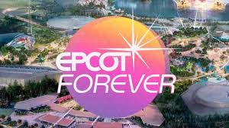

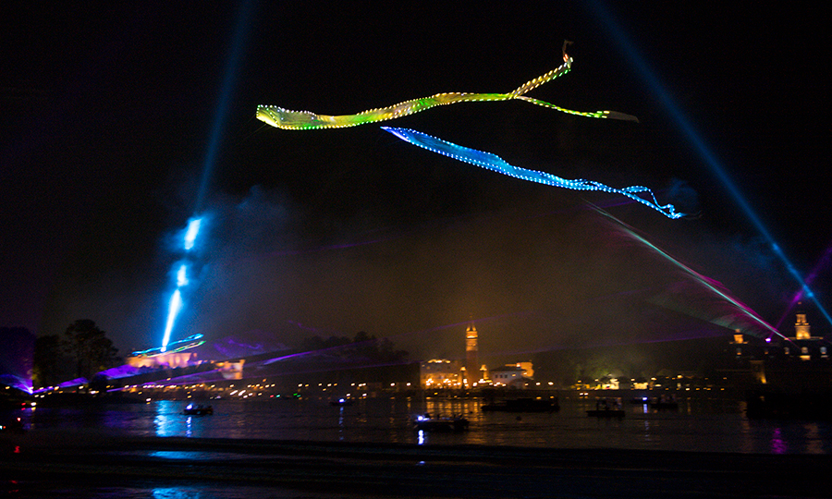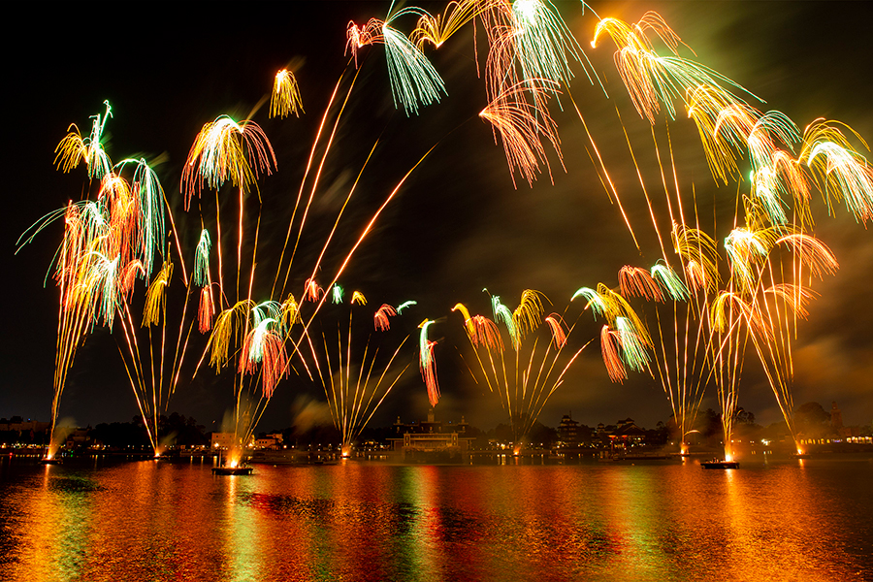
Epcot Forever is structured around medleys of Epcot music and the voices of children quoting different attractions, with some audio clips of Walt Disney in the EPCOT film also being incorporated into the opening and closing.
- Opening
  - "Legacy" (Epcot entrance music)
  - "One Little Spark" (from Journey into Imagination)
  - "We've Just Begun to Dream" (from Epcot Center Grand Opening)
- Innovation ("Welcome to the future... or, should I say, your future!" - Spaceship Earth)
  - "New Horizons" (from Horizons)
  - "Universe of Energy" (from Universe of Energy)
  - "Listen to the Land" (from Listen to the Land)
  - "New Horizons" (reprise, from Horizons)
- Exploration ("Soarin' to tower, we are ready for takeoff!" - Soarin')
  - "Tomorrow's Child" (from Spaceship Earth)
  - "Soarin'" (from Soarin')
  - "Magic Journeys" (from Magic Journeys)
  - "Tomorrow's Child" (reprise, from Spaceship Earth)
- Imagination ("And so, as you can plainly see, imagination works best when it's set free!" - Journey Into Imagination)
  - "One Little Spark" (reprise, from Journey into Imagination)
  - "Makin' Memories" (from Magic Journeys pre-show)
  - "Veggie, Veggie, Fruit, Fruit" (from Kitchen Kabaret)
  - "It's Fun to Be Free" (from World of Motion)
- Celebration ("May peace go with you forever and ever as you celebrate the future hand in hand" - Tapestry of Nations)
  - "Tapestry of Nations" (from Tapestry of Nations)
  - "Golden Dream" (from The American Adventure)
  - "Celebrate the Future, Hand in Hand" (from the Walt Disney World Millennium Celebration)
- Finale
  - "One Little Spark" (reprise with new lyrics, from Journey into Imagination)
  - "A Whole New World" (from Aladdin)

