2 : “Illuminations: Reflections of Earth”

1982 – 1996 1996 – 2009 2019 -
World Showcase
World Discovery World Celebration World Nature

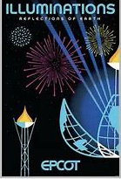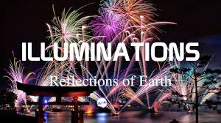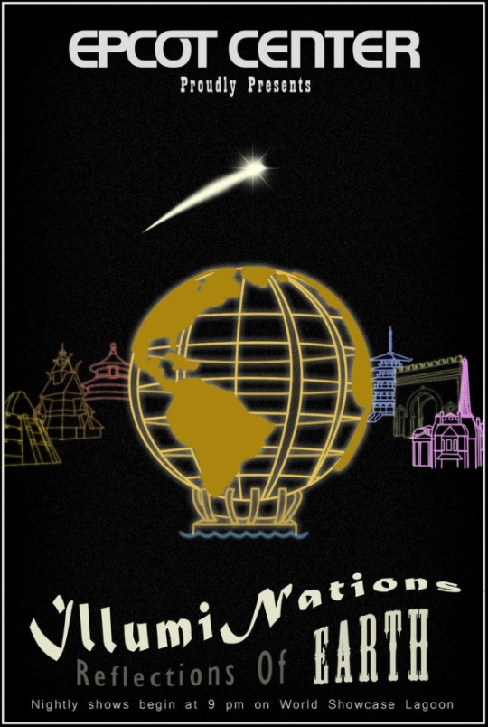

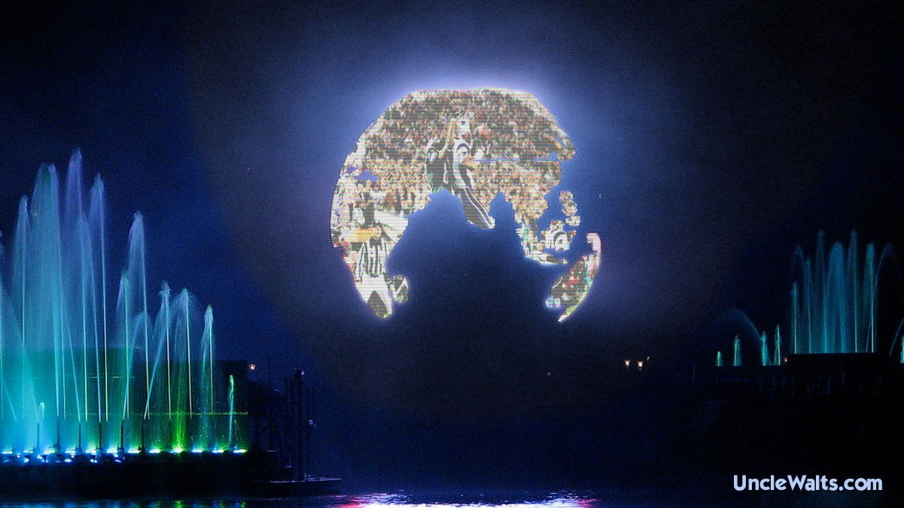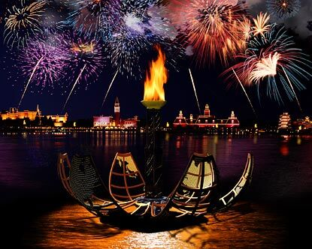
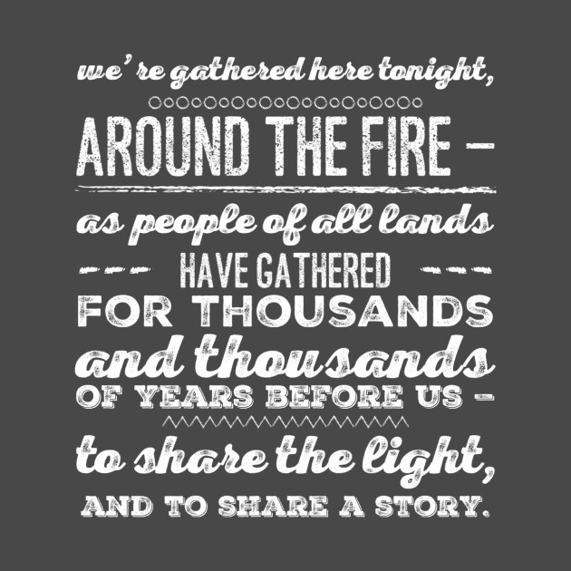

“Good evening. On behalf of Walt Disney World, the place where dreams come true, we welcome all of you to Epcot and World Showcase. We've gathered here tonight. around the fire, as people of all lands have gathered for thousands and thousands of years before us... to share the light... and to share a story. An amazing story as old as time itself, but still being written. And though each of us has our own individual stories to tell, a true adventure emerges when we bring them all together as one. We hope you enjoy our story tonight: Reflections of Earth.”

Act I: Chaos

Chaos represents the creation of the planet Earth. The show began with explosive fireworks from the center of the lagoon and hot flames from the Inferno Barge.

Act II: Order

Space Life Adventure Home Celebration

The spouting flames from the Flame Barge were reduced to a low sputter, and the Earth Globe appeared and moved towards the center of the lagoon accompanied with water effects emanating from the fountain barges. As the Globe cools, it changed from hot white to red to blue. Images appeared on the Globe of countries, famous landmarks, objects, and people. The exterior buildings of the countries around the lagoon were illuminated followed by laser lights, spotlights, and more fireworks in the center lagoon. (As the buildings of the Morocco Pavilion are replicas of ones that have a great religious significance, it did not light up during the show. In order to keep symmetry, the Norway Pavilion did not light up either.)

Act III: Meaning

As the song "We Go On" is played, the torches around the lagoon are relit and the Globe opened to reveal a final unity torch with emanating fireworks followed by a launch of 1,000 white fireworks brightly illuminating the lagoon. The scene concluded with a final launch of fireworks and a set of bright white flashes that ended with a loud crackle. The finale crackle emanating from the final launch set of fireworks could often be heard within several miles outside the park.

Post Show
The show ended with a post-show announcement:
“Ladies and gentlemen, the entire Epcot family thanks you for having been with us for 'Illuminations: Reflections of Earth', presented by Siemens. We hope that your visit to the Walt Disney World Resort has been a truly magical experience for you and yours. We wish you a pleasant evening and a safe journey home. Thank you and goodnight.”

Le Carnival de Lumiere – 1982 -- 1983
A New World Fantasy – 1983 -- 1984
Lazerphonic Fantasy – 1984 – 1988
Illuminations – 1988 -- 1999
Illuminations: Reflections of Earth – Oct 1999 – Sep 2019
Epcot Forever – Oct 2019 – Sep 2020
HarmonioUS – Oct 2020 -- ?
