<<< Disney Night Parades – OLLI – Winter 2021 >>>
www.mh3wv.org/olli
===================================================================

6 – Tokyo Disneyland Overview

“DreamLights”

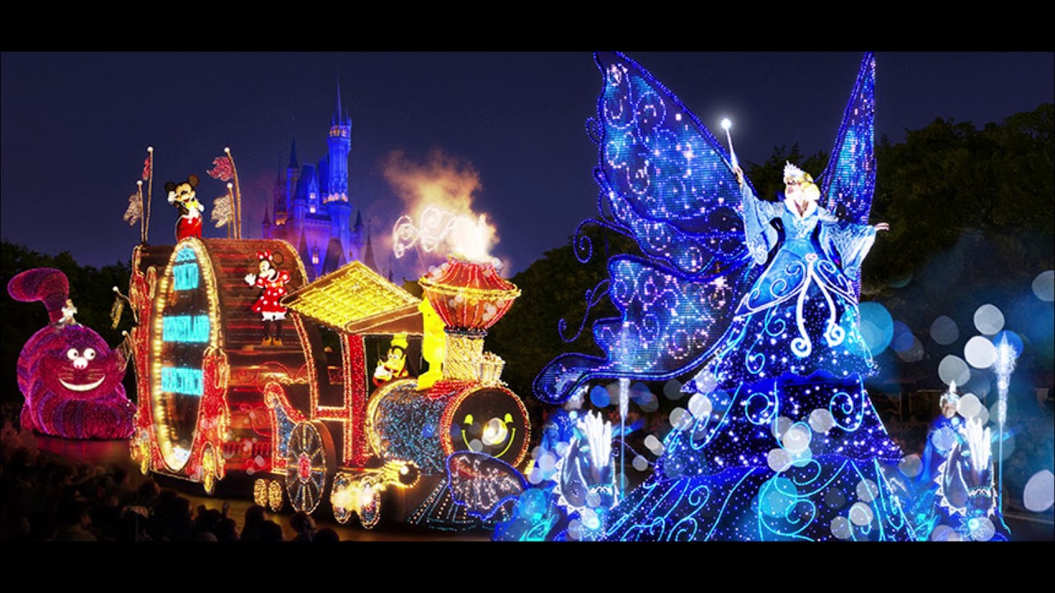
2001 – Present
