<<< Disney Night Parades – OLLI – Winter 2021 >>>
www.mh3wv.org/olli
===================================================================

3 – Magic Kingdom Overview – “SpectroMagic”
Oct 1, 1991 – May, 1999 April 2001 – June 4, 2010

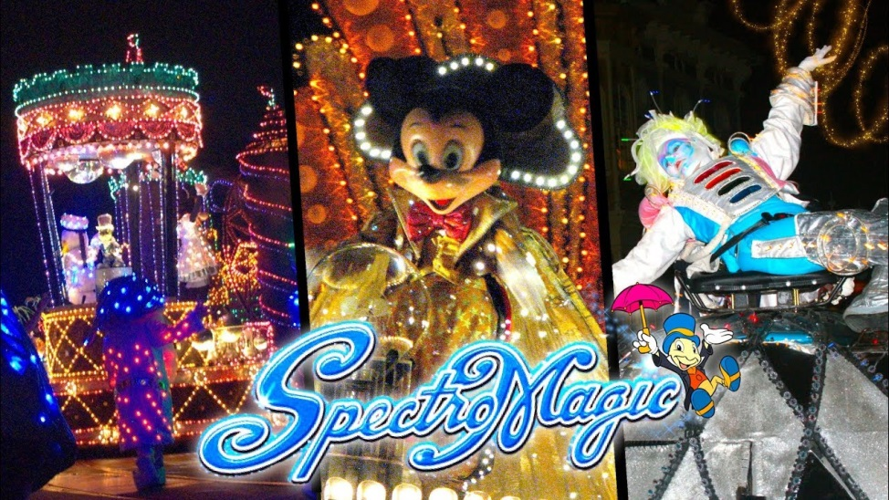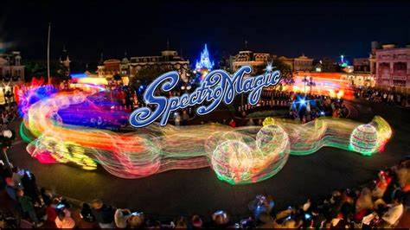

Lyrics
ADULT VOICES] On this magic night, A million stars will play beside us, Cast a spell of light, Glimmering, shimmering, carousel-ling 'Round the world tonight, A symphony in SpectroMagic. Pure enchantment lights our way!
[JIMINY CRICKET] "Welcome to the splendor, the spectacle, the sparkling sensation, where the comedy and thrill of Disney fantasies come to electric life.
And now, the Magic Kingdom proudly presents, in a million points of musical light, the magic worlds of Disney...in SpectroMagic!"
[CHILDREN'S VOICES] Music surrounds us Laughter that found us Twirling around this Carousel of light and laughter!
We shall remember This moment together Let this night forever Live in our dreams!
[ALL] On this magic night, A million stars will play beside us, A special spell of light, Glimmering, shimmering, carousel-ling 'Round the world tonight, A symphony in SpectroMagic. Pure enchantment lights our way!
[CHILDREN'S VOICES] Music surrounds us Magic around us Twirling around us Carousel of light and laughter!
Though we say goodbye We cast a spell that won't be broken Let this night forever Live in our dreams!
[JIMINY CRICKET] So long! See ya later!
[ALL] On this magic night, A million stars will play beside us, A special spell of light, Glimmering, shimmering, carousel-ling 'Round the world tonight, A symphony in SpectroMagic. Pure enchantment lights our way!
[JIMINY CRICKET] So long! I'm Jiminy Cricket...in SpectroMagic!

The Story
The parade is about Mickey Mouse, along with the SpectroMagic Spectromen, who together create the power of SpectroMagic. After the first part of the Parade with Mickey Mouse and the SpectroMagic Spectromen, the parade then takes you though five different themes:
- "The Worlds of Music from the Silly Symphonies"
- "The Wonder of Sleeping Beauty's Garden"
- "The Fantasy of The Little Mermaids Ocean"
- "The Imagination of Fantasia"
- "And the World of Dreams in a Grand Disney Cavalcade"

