<<< Disney Night Parades – OLLI – Winter 2021 >>>
www.mh3wv.org/olli
===================================================================
2 – Disneyland Resort Area Overview (July 17, 1955) –
“The Main Street Electrical Parade”

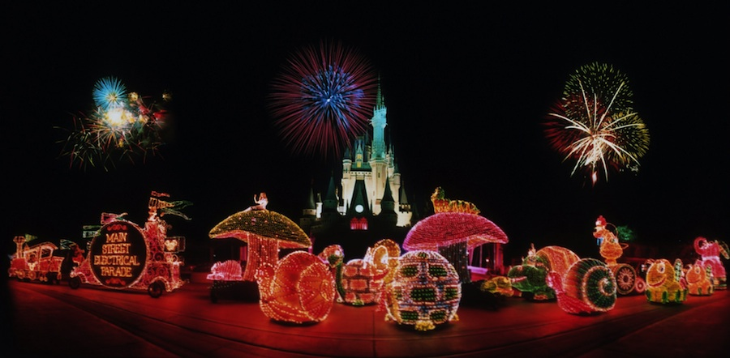

DL – June 17, 1972 MK (WDW) – June 11, 1977 DLP (Paris) – April 12, 1992
DCA -- July 2, 2001 NYC – June 14, 1997 TDL -- March 9, 1985

