Thirteen: Disneyland – “Fantasmic”

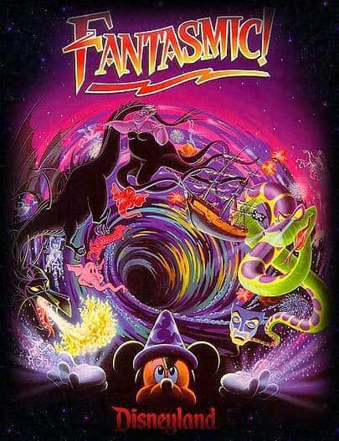

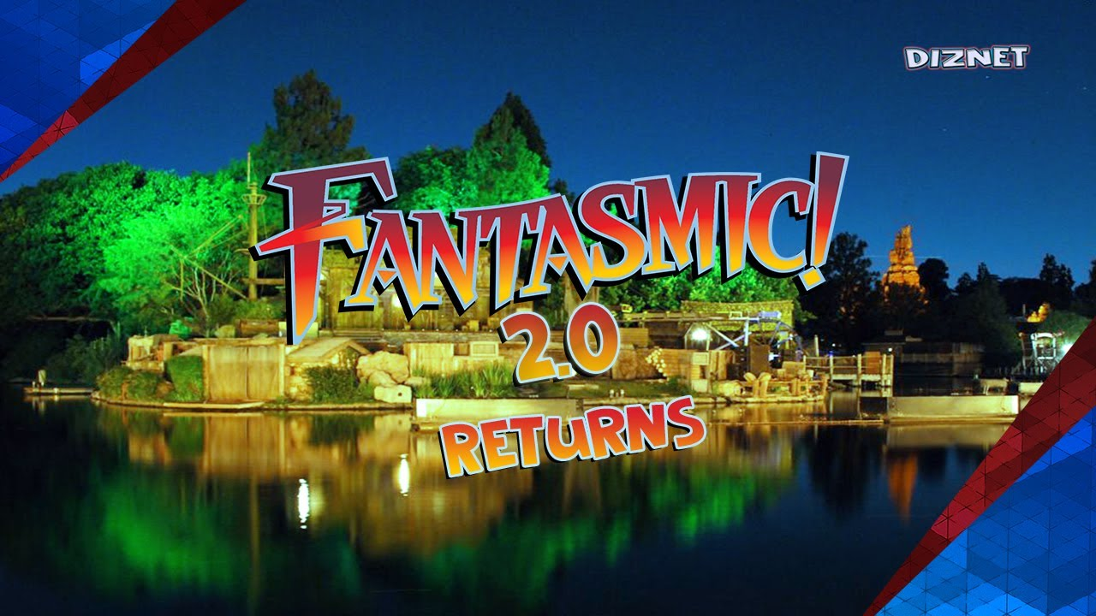

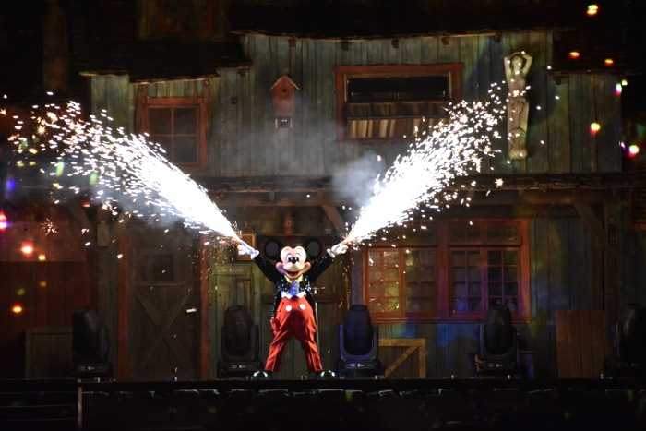

“When Dreams Come to Life”
“Fast asleep, Mickey dreams he is the Sorcerer’s Apprentice. With a wave of his hands, he conducts scenes from Fantasia across enormous screens of water while brilliant sparks burst overhead. Pink elephants, swashbuckling pirates, princesses and more appear on and around the Rivers of America.
“When Mickey is suddenly pulled into the Magic Mirror, his dream takes a dark turn. The Evil Queen from Snow White conjures up some of Disney's most dastardly villains—including Maleficent as a 45-foot, fire-breathing dragon! Mickey must use the power of his imagination to vanquish his foes—and save the day!”

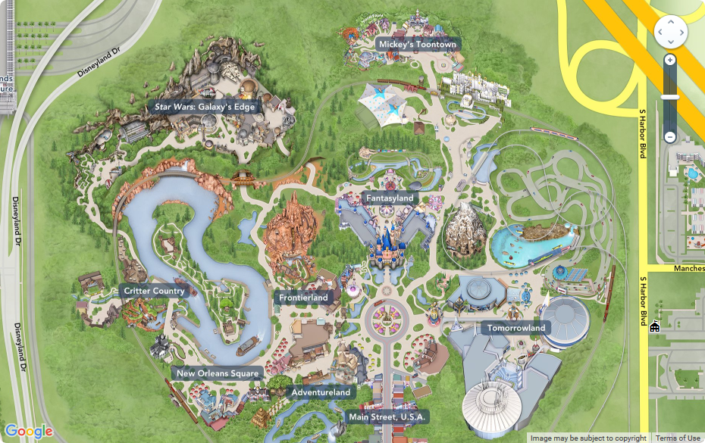
==================================================

Fourteen: Overview – Tokyo DisneySea – “Fantasmic”

