ELEVEN: Overview – Disney’s Animal Kingdom
“Rivers Of Light”

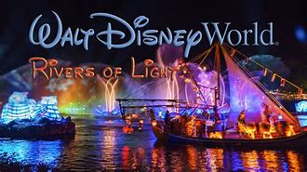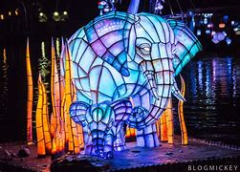

Act I: Gifts of Light
Before the show begins, four lotus floats gradually drift onto the Discovery River Lagoon while fireflies awaken and the shadows of the four Animal Spirit Guides can be seen moving through the trees. The fireflies function as a visual element throughout the show, seemingly illuminating barges and occasionally accenting visual elements projected on water screens.
The show begins with the arrival of two teams of mystical storytellers on their respective lantern sailboats, playing a musical fanfare accompanied by the cries of animals. On the Asia side of the lagoon are Shaman Aditya (whose instrument is a horn) and Acolyte Ketu, representing the element of fire. On the Dinoland side of the lagoon are Shaman Aseema (whose instrument is a flute) and her Acolyte Ambu, representing the element of water. These characters are silent and communicate only through pantomime, dance, shadow puppetry, and music, leaving a narrator to explain what we are about to see.
“Of all the gleaming planets in our vast universe, it is only here on Earth that water and light harmoniously unite to create the wonder of life. We most graciously welcome you to a timeless celebration of water and light with roots as far reaching as time itself. Here, where the forces of nature meet in harmony, the spirits of the animals are free to dance together in the night sky creating Rivers of Light. We are united in this special place to celebrate the magnificence and wonder of all living creatures, for in life, we are all one.”

Act II: Parade of the Animal Spirits

As the narration ends, the storytellers introduce us to the four Animal Spirit guides, each representing one of the four elements. Taking the form of large sculpted lantern barges, they consist of a Tiger (representing Fire), an African Elephant and her calf (representing Earth), a Sea Turtle and its offspring (representing Water), and a Great Horned Owl with her owlets (representing Air). Moving across the lagoon and changing color to the music, the Animal Spirits begin to leave their lanterns one by one and take to the sky in an astral form, bringing the lotuses to life and heralding the arrival of the Temple Lotus.

Act III: Dance of the Lotus

After the animal spirits have left their lanterns, the lotuses take center stage, flanking the central Temple Lotus barge. Aseema conducts the lotuses in their fountain ballet and has the shadow puppet-like figures of the turtle and owls dance amongst them on the water while the storytellers provide percussion.

Act IV: We Are One

After the Dance of the Lotus ends, Aditya plays his horn to call the Tiger spirit into action, who proceeds to leapfrog across the lotuses and begin a journey through the different realms of the Animal Spirits. Accompanied by the original song "We Are One" and utilizing footage taken from the Disney Nature documentary series, we travel through the tiger's dense jungles, the sea turtle's ocean home and the savanna of the African Elephant. The song is interrupted by a scene taken from “African Cats,” where a lion chases after a mother cheetah on its territory, who manages to make a narrow escape and get her cubs to safety. Aseema and her boat reappear and she sends the owl up from her boat to take us to the snowy regions of Alaska seen in “Bears” and the song resumes with a montage of animal families, ending on a flock of flamingos and the sounds of Aseema and Aditya's instruments as the two boats go back to center stage.

Act V: Rivers of Light

In a scene inspired visually and musically by the "Transformation" sequence in Brother Bear, the storytellers call upon the aurora borealis (the titular "Rivers of Light"), which starts to appear over the lagoon. Spirits of countless animals begin rushing and marching through the lights as the storytellers bask in the beautiful glow. The aurora fades on an image of a humpback whale breach and gives way to the night sky and animals in the constellations. As the Animal Spirit Guides return to their lantern barges, the narrator returns for concluding remarks.
“Within each of us is a light. A light that shines in all living things. Here where fire and water bridge the earth and sky, our light rises on the wind to join the stars. As we journey on this great earth, may we remember the light we share? May we celebrate our bond with the natural world and the wonders that flow on Rivers of Light.”
The Temple Lotus opens up to reveal a tower of fire that blasts to the beat of a grand finale reprise of We Are One. The animals return and the fireflies emerge from the Tree of Life in the form of spotlights

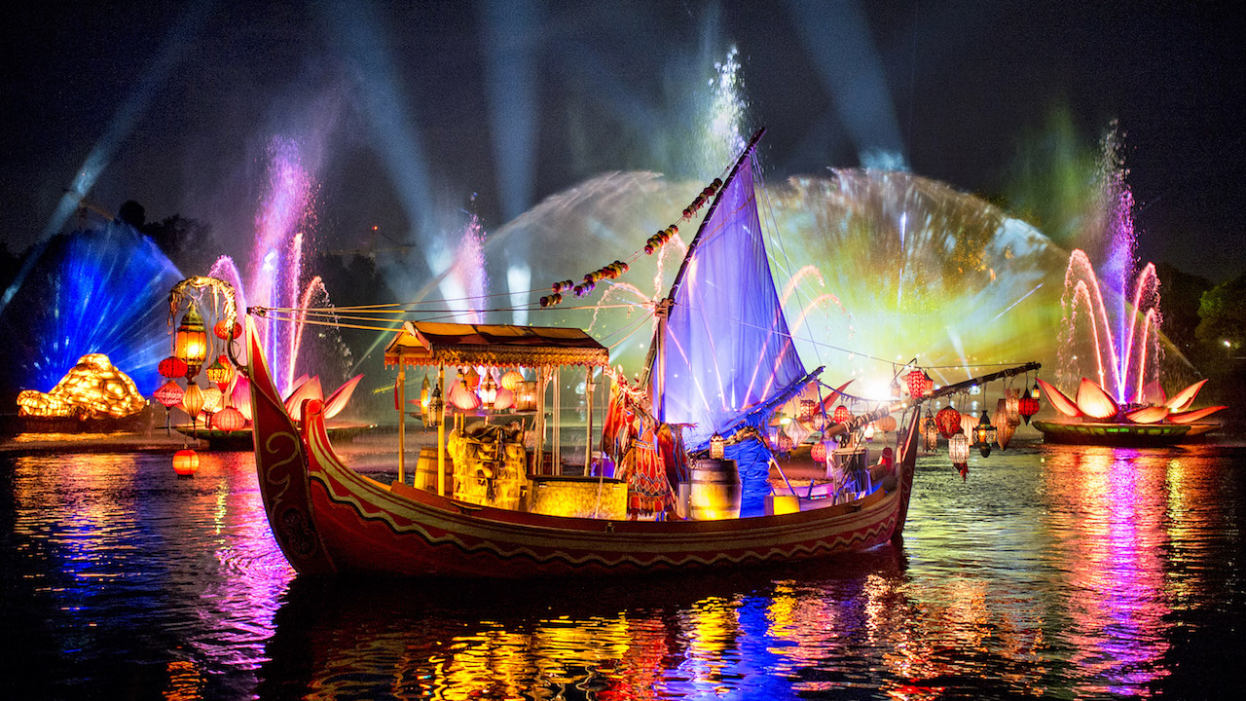
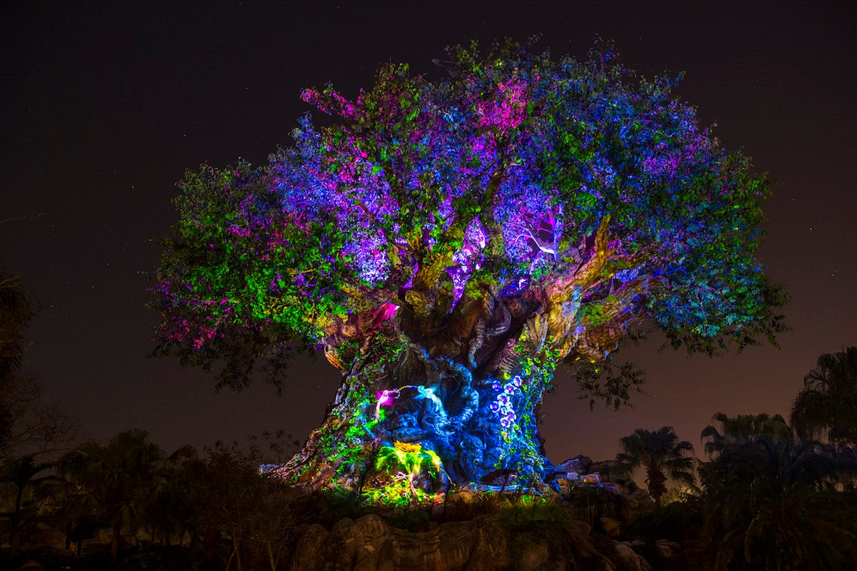
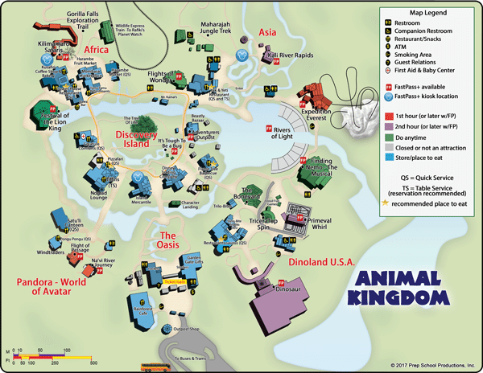

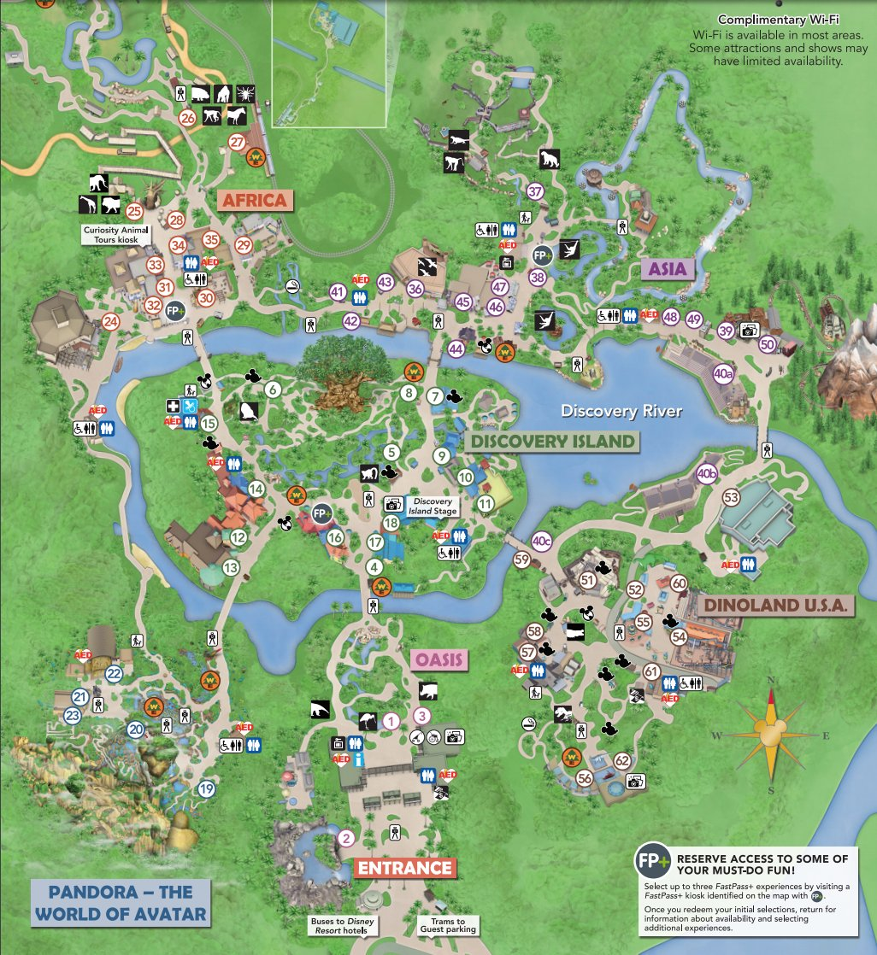

====================================================
TWELVE: Overview – Disney California Adventure
“World of Color”
“Watch in wonder as water, fire, light, and music weave together to celebrate the magic of Disney Storytelling.”
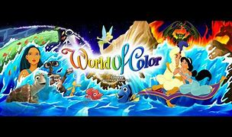
"Every child is blessed with a vivid imagination"
