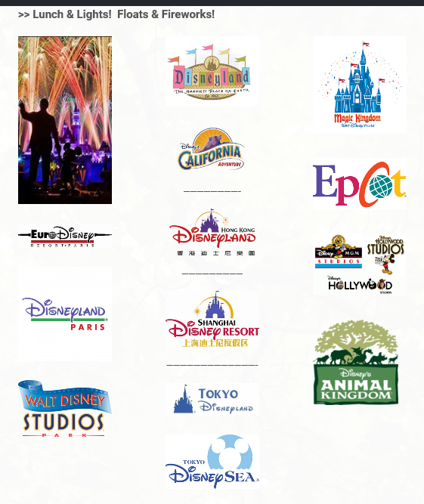
Disneyland (DL) - 1955
Magic Kingdom (MK) – 1971
EPCOT (EC) (nee Epcot Center) – 1982
Tokyo Disneyland (TDL) – 1983
Disney Hollywood Studios (ST) (nee Disney-MGM Studios) – 1989
Disneyland Paris (DLP) (nee EuroDisney) – 1992
Animal Kingdom (AK) - 1998
Tokyo DisneySea (TDS) – 2001
Disney California Adventure (DCA) – 2001
Walt Disney Studios (WDS) - 2002
Hong Kong Disneyland (HK) – 2005
Shanghai Disneyland – 2016
SEVEN: Overview -- Walt Disney World / Epcot Center -
“Illuminations” (the original)
---------------------------------------------------------------------------------------------------------------------------------------------
Future World
World Nature World Celebration World Discovery
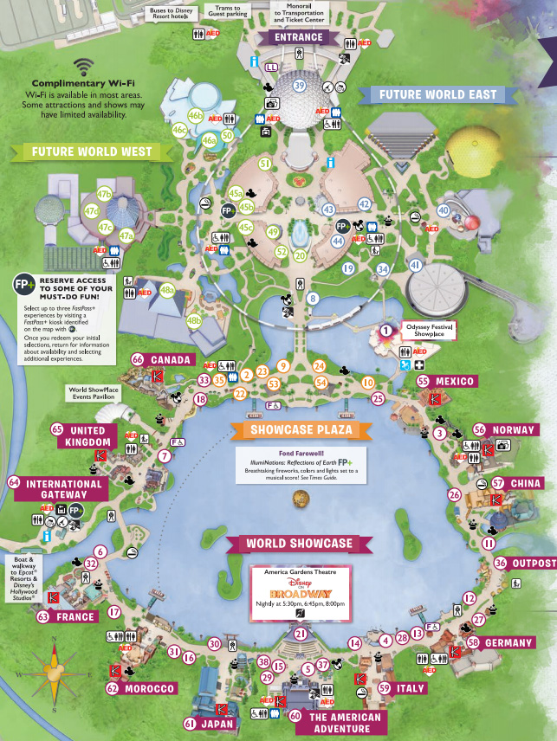
World Showcase
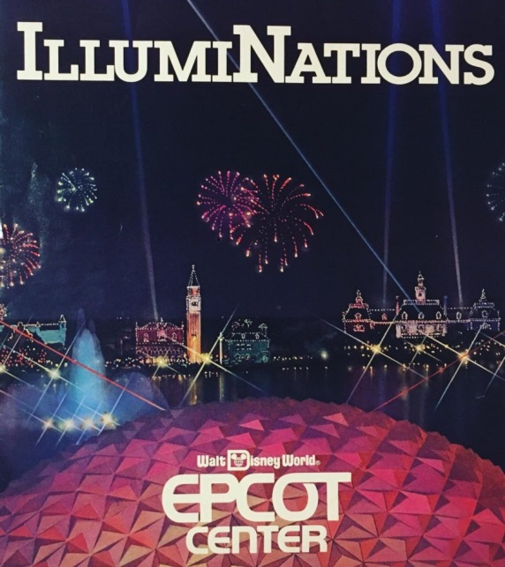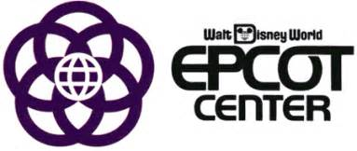
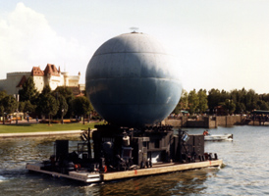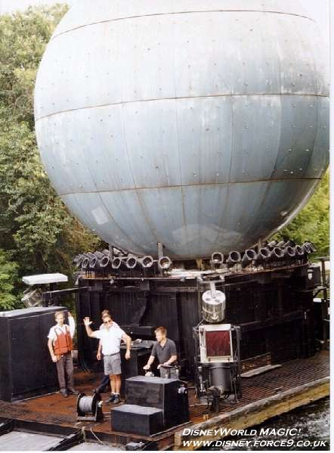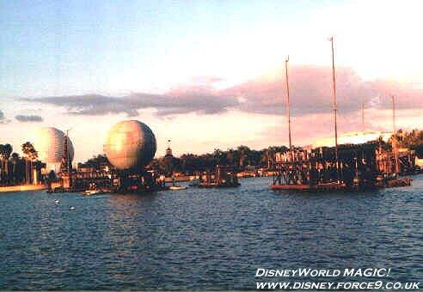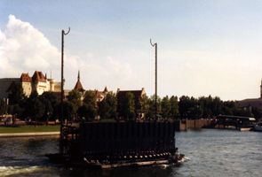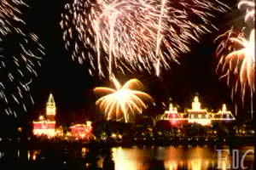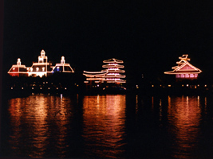
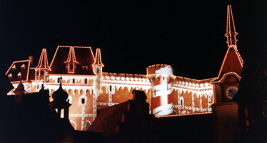
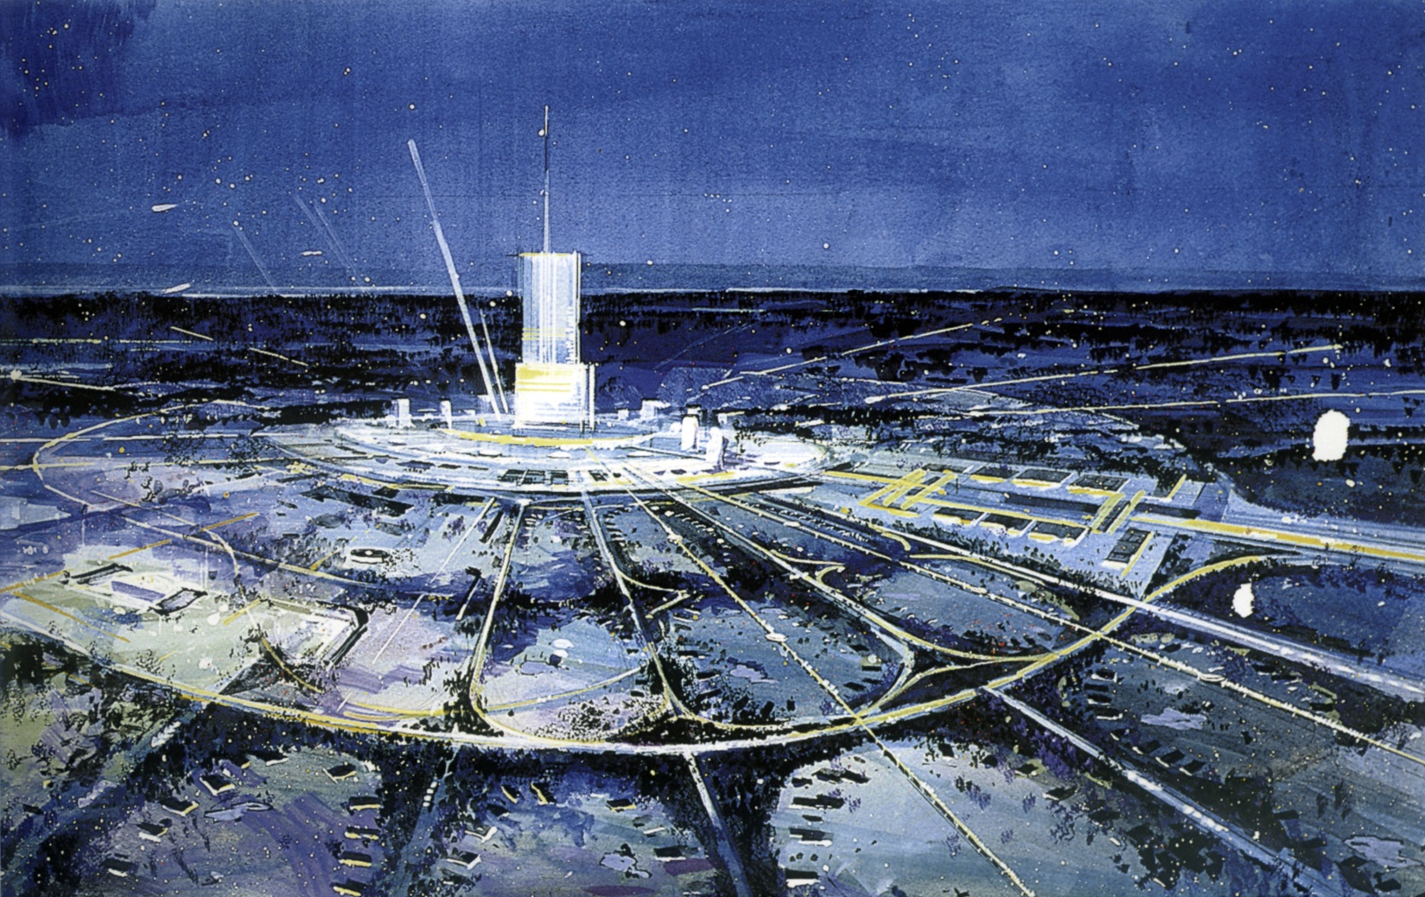
Le Carnival de Lumiere – 1982 -- 1983
A New World Fantasy – 1983 -- 1984
Lazerphonic Fantasy – 1984 – 1988
Illuminations – 1988 -- 1999
Illuminations: Reflections of Earth – Oct 1999 – Sep 2019
Epcot Forever – Oct 2019 – Sep 2020
HarmonioUS – Oct 2020 -- ?
============================================================================
EIGHT – Overview – Walt Disney World -
“Illuminations:Reflections of Earth”
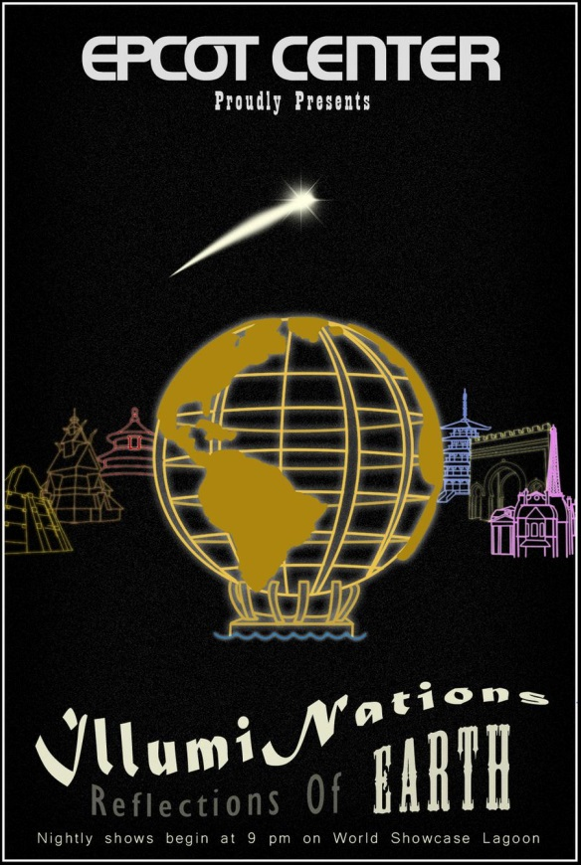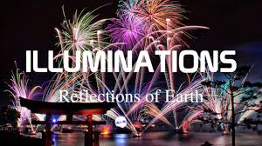
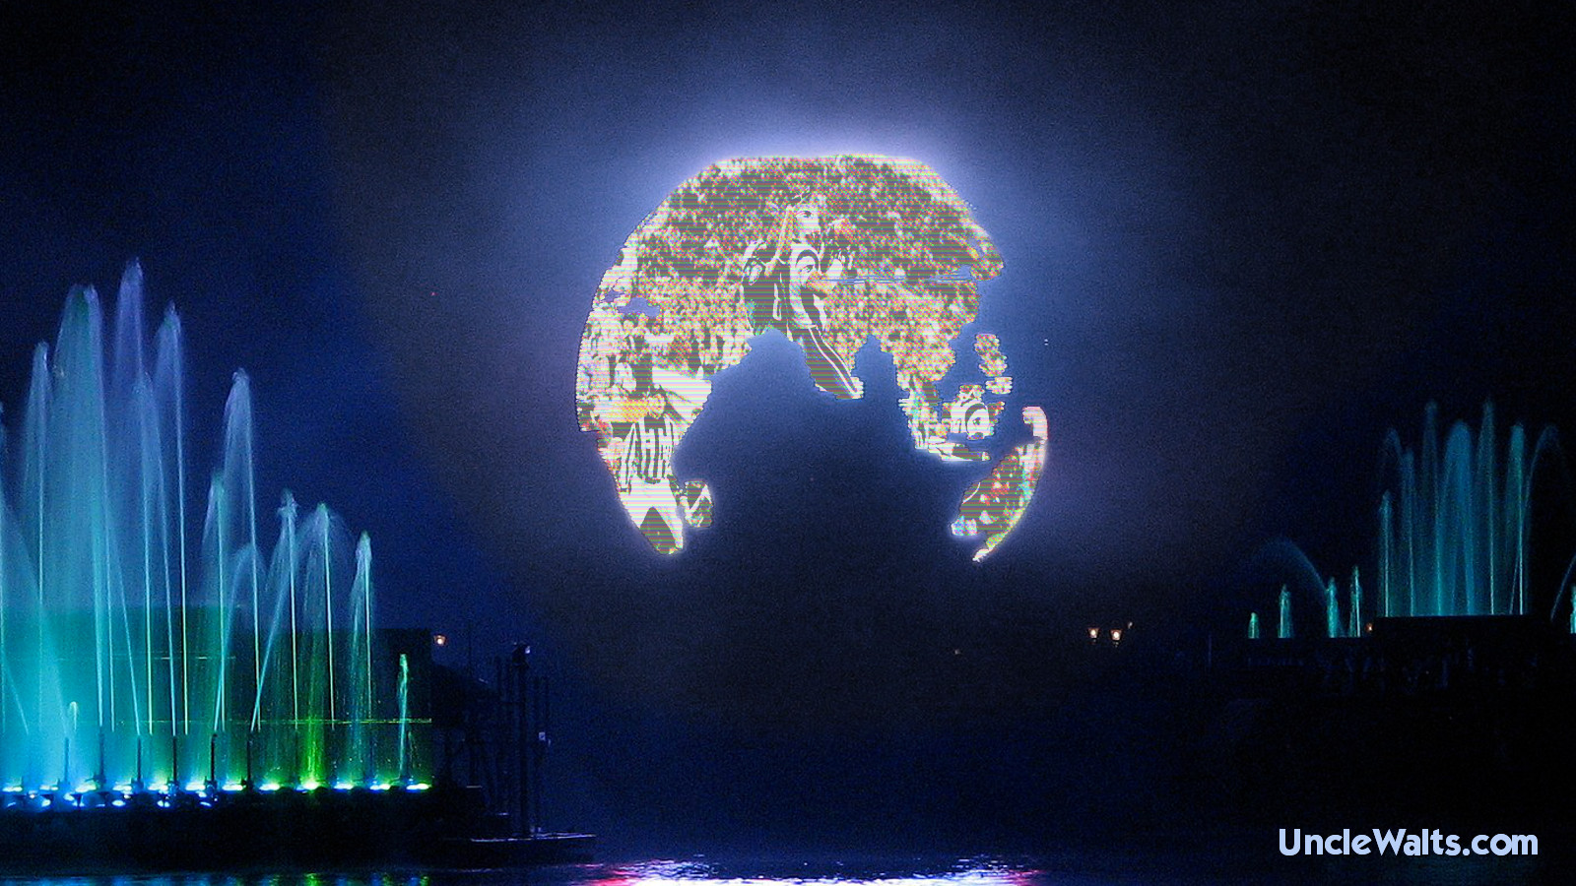
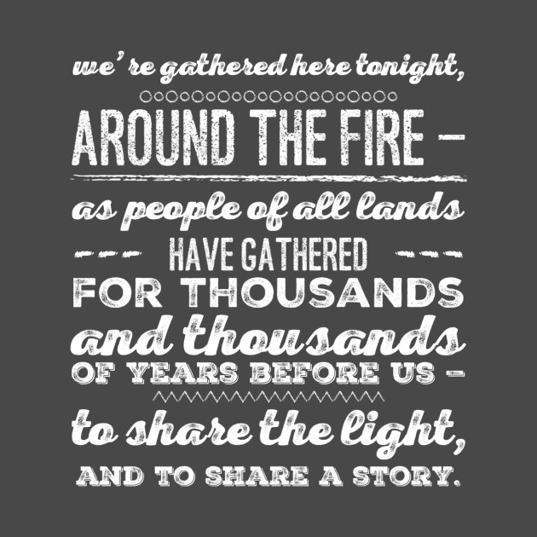
“Good evening. On behalf of Walt Disney World, the place where dreams come true, we welcome all of you to Epcot and World Showcase. We've gathered here tonight. around the fire, as people of all lands have gathered for thousands and thousands of years before us... to share the light... and to share a story. An amazing story as old as time itself, but still being written. And though each of us has our own individual stories to tell, a true adventure emerges when we bring them all together as one. We hope you enjoy our story tonight: Reflections of Earth.”

Act I: Chaos

Act II: Order

Space Life Adventure Home Celebration

Act III: Meaning

======================================================================




